**Project Planning Phase**

**Project Planning Template (Product Backlog, Sprint Planning, Stories, Story points)**

|  |  |
| --- | --- |
| Date | 22nd October 2022 |
| Team ID | PNT2022TMID23263 |
| Project Name | Analytics for Hospital Health Data |
| Maximum Marks | 8 Marks |

**Product Backlog, Sprint Schedule, and Estimation (4 Marks)**

|  |  |  |  |  |  |  |
| --- | --- | --- | --- | --- | --- | --- |
| **Sprint** | **Functional**  **Requirement (Epic)** | **User Story Number** | **User Story / Task** | **Story Points** | **Priority** | **Team**  **Members** |
| Sprint-1 | Registration | USN-1 | As a user, I can register for the application by entering my email, password, and confirming my password. | 2 | High | Pandidurai M |
| Sprint-1 |  | USN-2 | As a user, I will receive confirmation email once I have registered for the application | 1 | High | Venkateshbabu BB |
| Sprint-2 |  | USN-3 | As a user, I can register for the application through Facebook | 2 | Low | Abdul Rahuman R |
| Sprint-2 |  | USN-4 | As a user, I can register for the application through Gmail | 2 | Medium | Udaya Shankar M |
| Sprint-2 | Login | USN-5 | As a user, I can log into the application by entering email & password | 1 | High | Pandidurai M |
| Sprint-3 | Dashboard | USN-6 | As a user ,I can use my account in my dashboard for uploading dataset. | 5 | Medium | Venkateshbabu BB |
| Sprint-3 | Website | USN-7 | As a user ,I can use my dashboard in website | 3 | Medium | Pandidurai M |
| Sprint-4 | Dashboard | USN-8 | As a user ,I can contact Customer care Executive for my login. | 5 | High | Pandidurai M |
| **Sprint** | **Functional**  **Requirement (Epic)** | **User Story**  **Number** | **User Story / Task** | **Story Points** | **Priority** | **Team**  **Members** |
| Sprint-4 | Dashboard | USN-9 | As a user ,I can contact administrator for my queries. | 5 | High | Abdul Rahuman R |
| Sprint-3 | Dashboard | USN-10 | As a user, I can prepare data by using Exploration Techniques. | 5 | High | Venkateshbabu BB |
| Sprint-4 | Dashboard | USN-11 | As a user, I can Present data in my dashboard. | 5 | High | Udaya Shankar M |
| Sprint-3 | Dashboard | USN-12 | As a user, I can Prepare Data by using Visualization Techniques. | 5 | High | Udaya Shankar M |

**Project Tracker, Velocity & Burndown Chart: (4 Marks)**

|  |  |  |  |  |  |  |
| --- | --- | --- | --- | --- | --- | --- |
| **Sprint** | **Total Story Points** | **Duration** | **Sprint Start Date** | **Sprint End Date (Planned)** | **Story Points**  **Completed (as on**  **Planned End Date)** | **Sprint Release Date (Actual)** |
| Sprint-1 | 3 | 6 Days | 24 Oct 2022 | 29 Oct 2022 | 3 | 29 Oct 2022 |
| Sprint-2 | 5 | 6 Days | 31 Oct 2022 | 05 Nov 2022 | 5 | 05 Nov 2022 |
| Sprint-3 | 18 | 6 Days | 07 Nov 2022 | 12 Nov 2022 | 18 | 12 Nov 2022 |
| Sprint-4 | 15 | 6 Days | 14 Nov 2022 | 19 Nov 2022 | 15 | 19 Nov 2022 |

**Velocity:**

|  |  |  |  |
| --- | --- | --- | --- |
| **Sprints** | **Sprint Duration** | **Velocity** | **Actual Velocity** |
| **Sprint-1** | 6 | 3 | 2 |
| **Sprint-2** | 6 | 5 | 1.2 |
| **Sprint-3** | 6 | 18 | 0.35 |
| **Sprint-4** | 6 | 15 | 0.4 |

# Velocity – Actual Velocity

**Burndown Chart:**

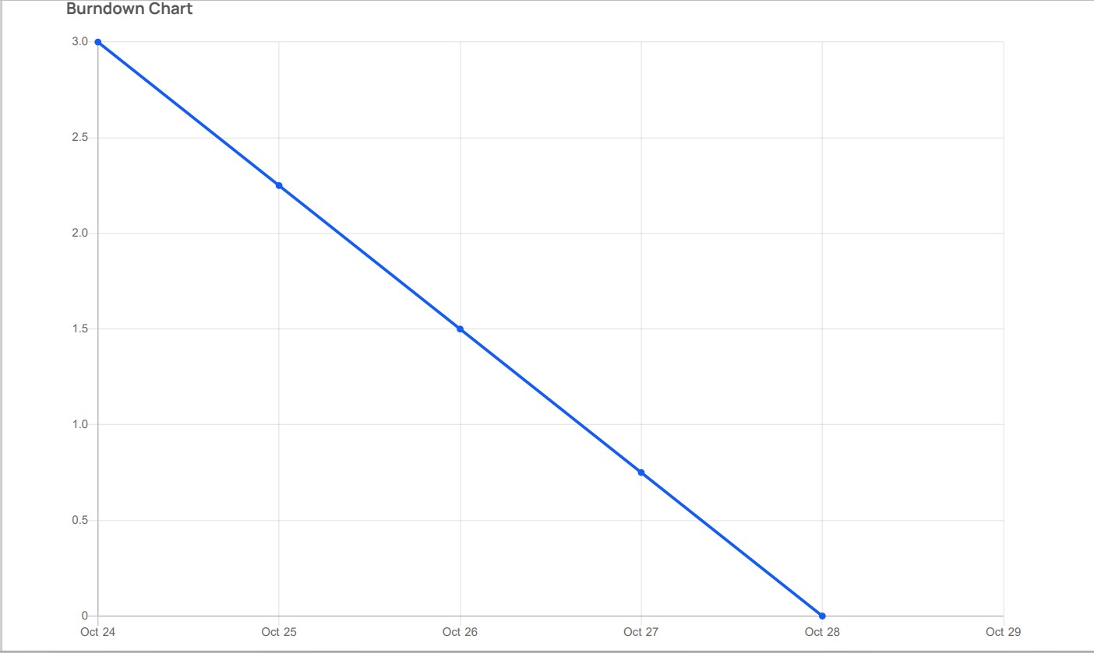

**SPRINT -1**

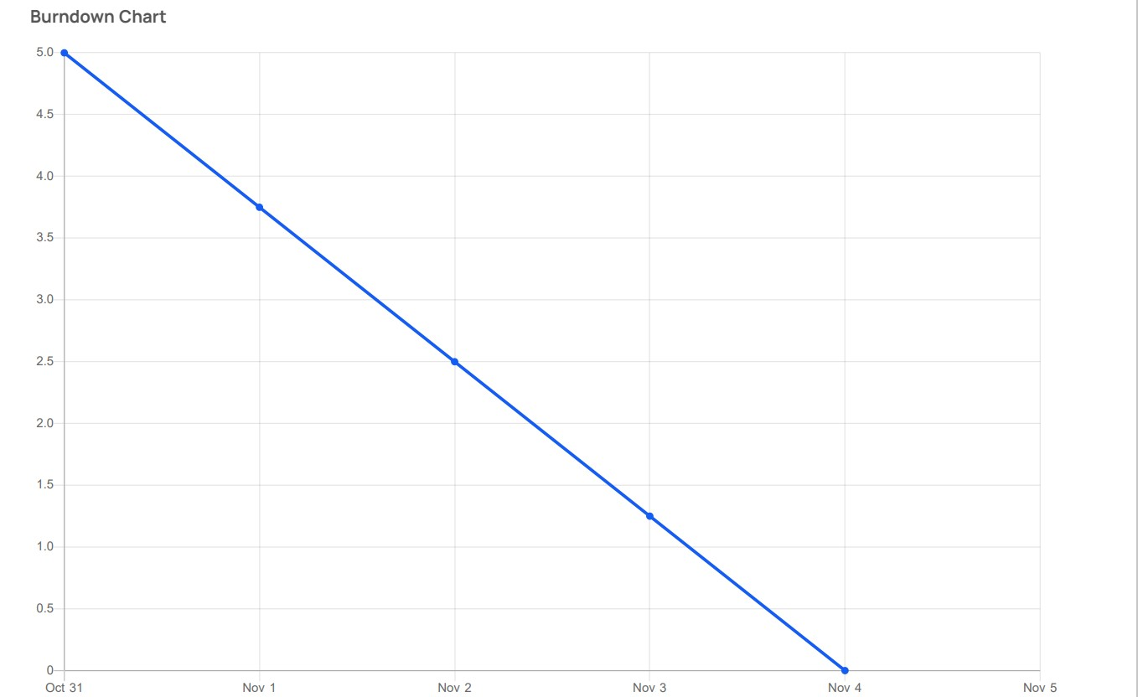

**SPRINT- 2**

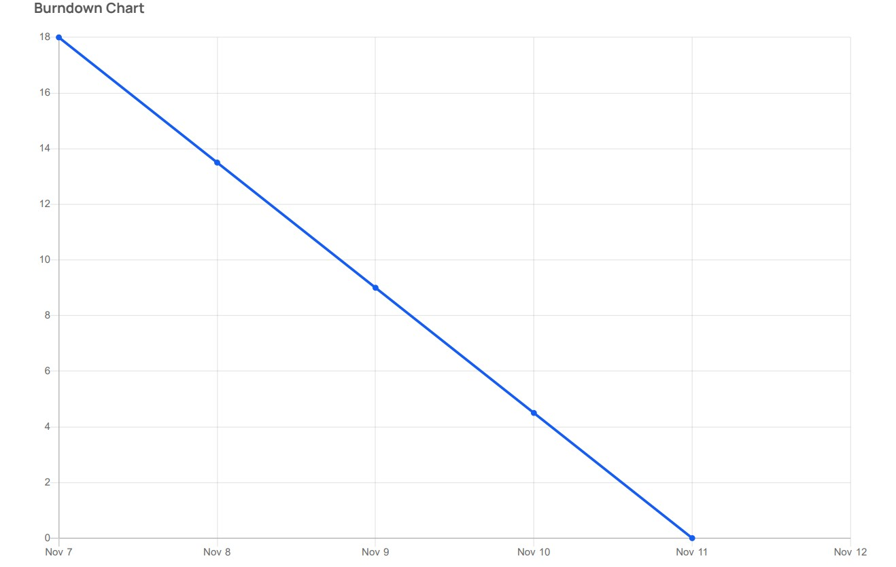

**SPRINT- 3**

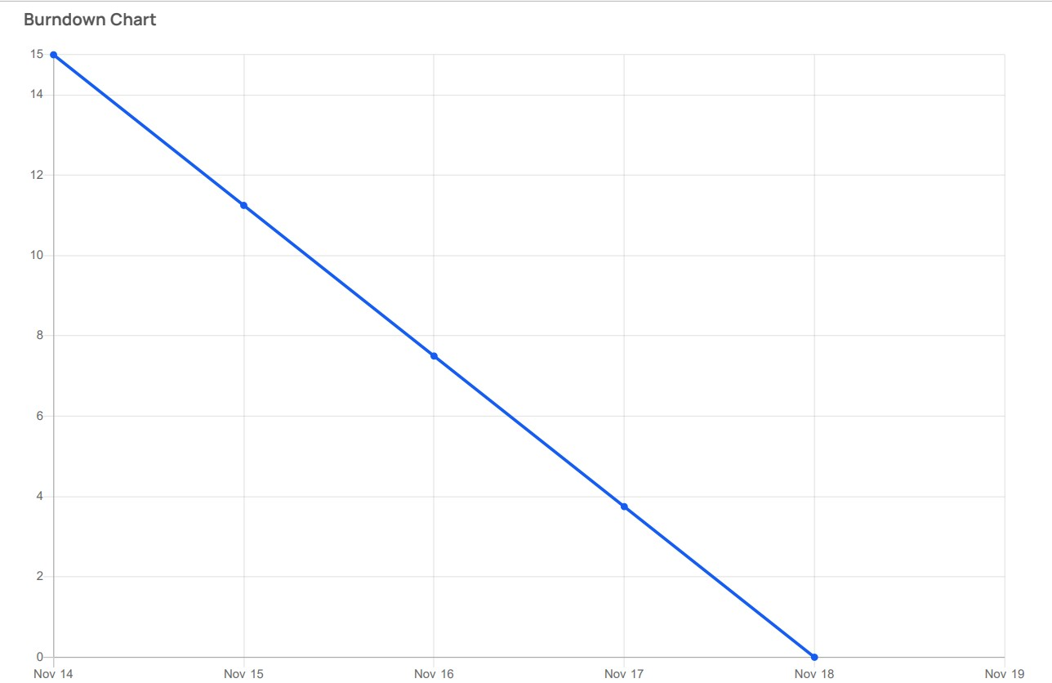

**SPRINT -4**

**Estimation:**

|  |  |  |  |  |  |  |  |
| --- | --- | --- | --- | --- | --- | --- | --- |
| **Sprints** | **Total Points** | **Day 0** | **Day 1** | **Day 2** | **Day 3** | **Day 4** | **Day 5** |
| Sprint-1 | 3 | 3 | 2.25 | 1.5 | 0.75 | 0 | 0 |
| Sprint-2 | 5 | 5 | 3.75 | 2.5 | 1.75 | 0 | 0 |
| Sprint-3 | 18 | 18 | 15 | 9 | 5 | 0 | 0 |
| Sprint-4 | 15 | 15 | 11.75 | 7.75 | 4 | 0 | 0 |

**Project Planning Tools:**

**JIRA Software:**

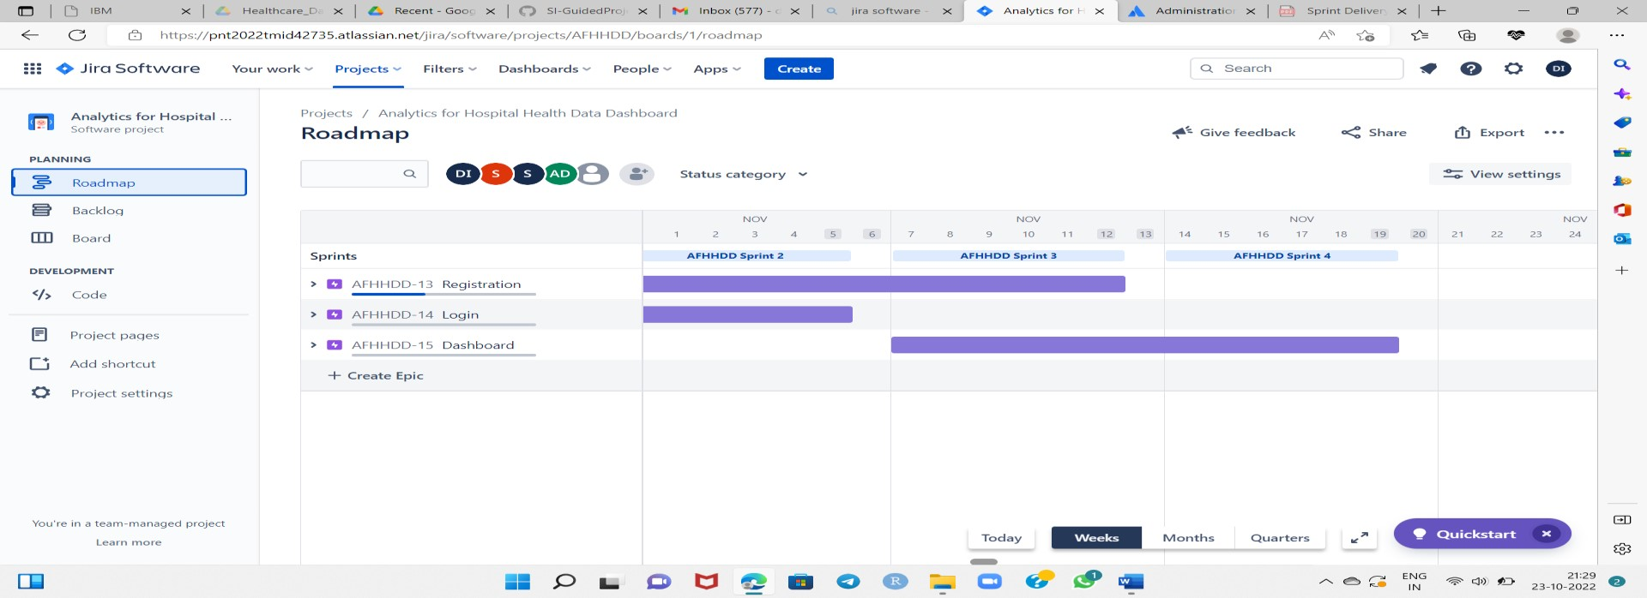

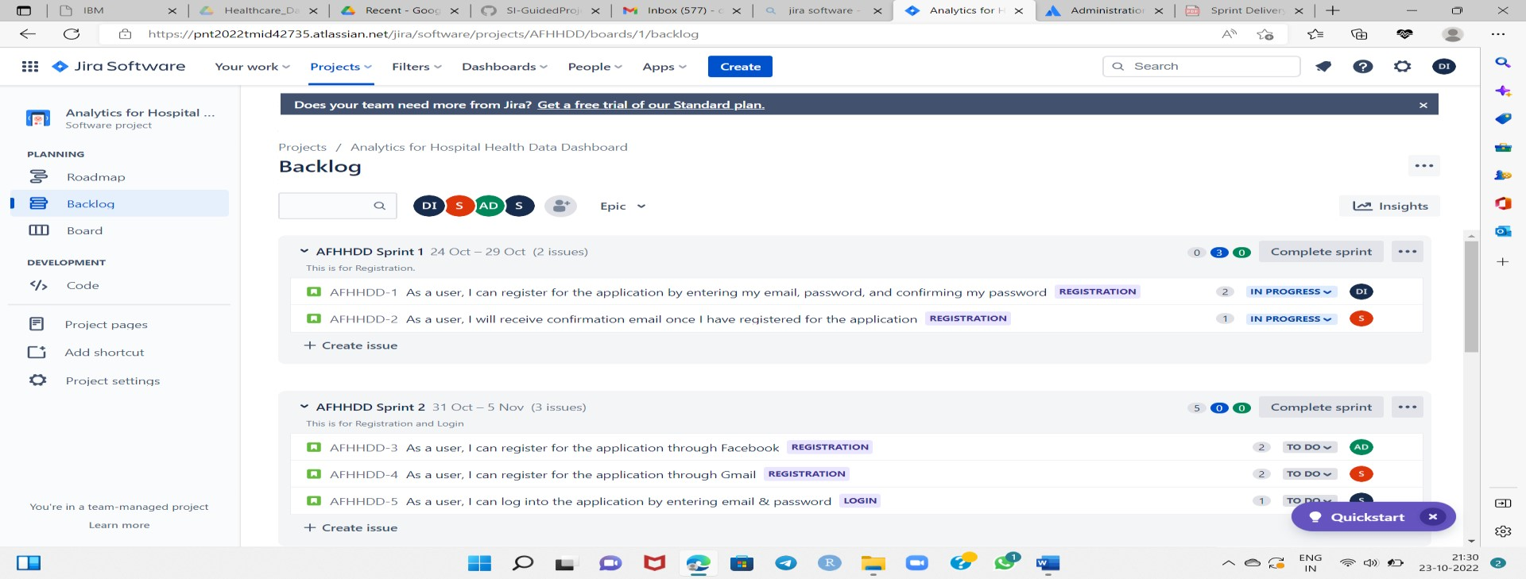

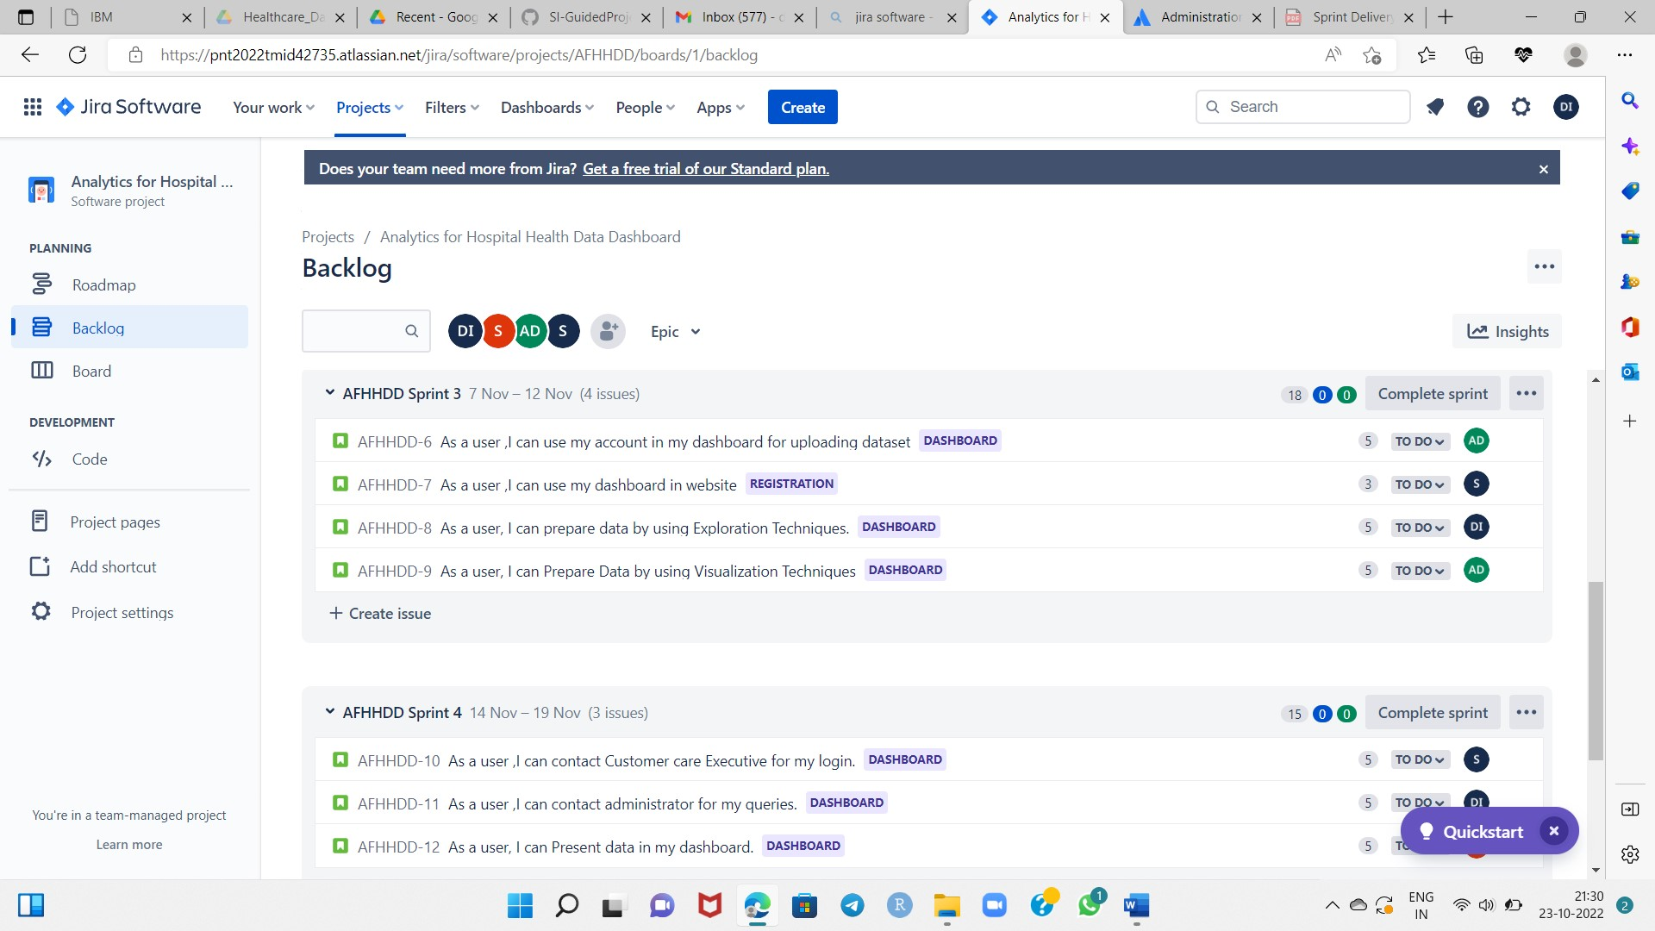

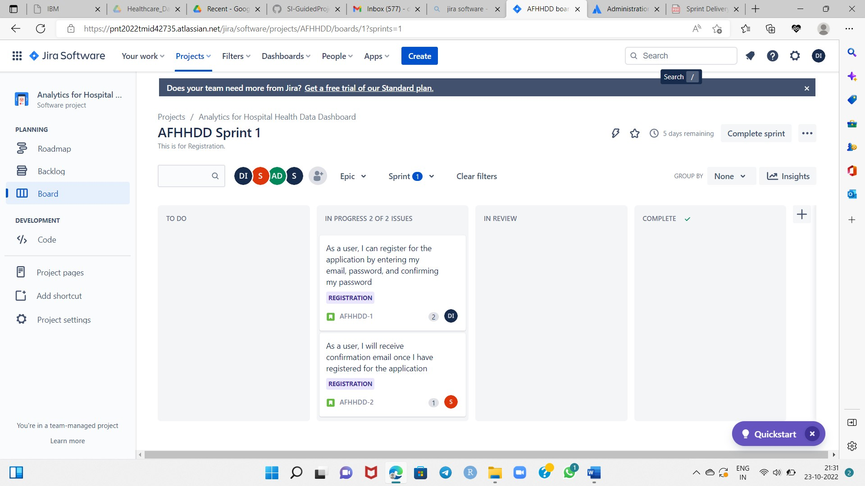

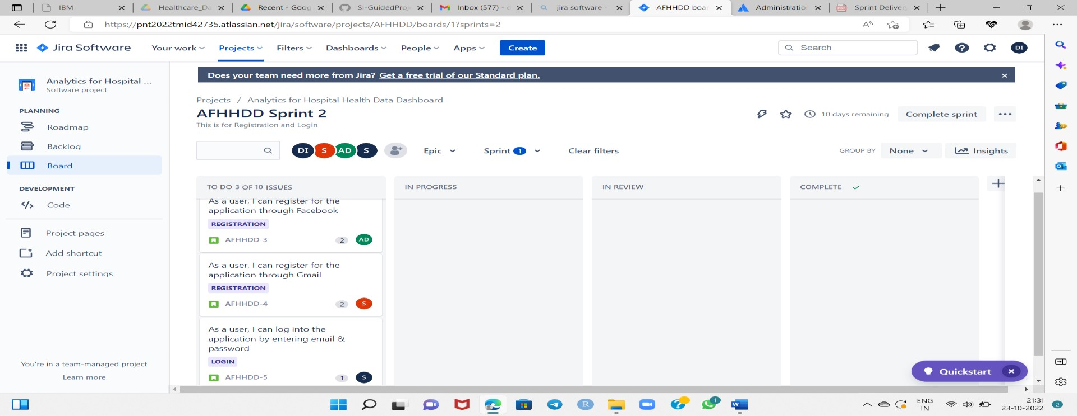

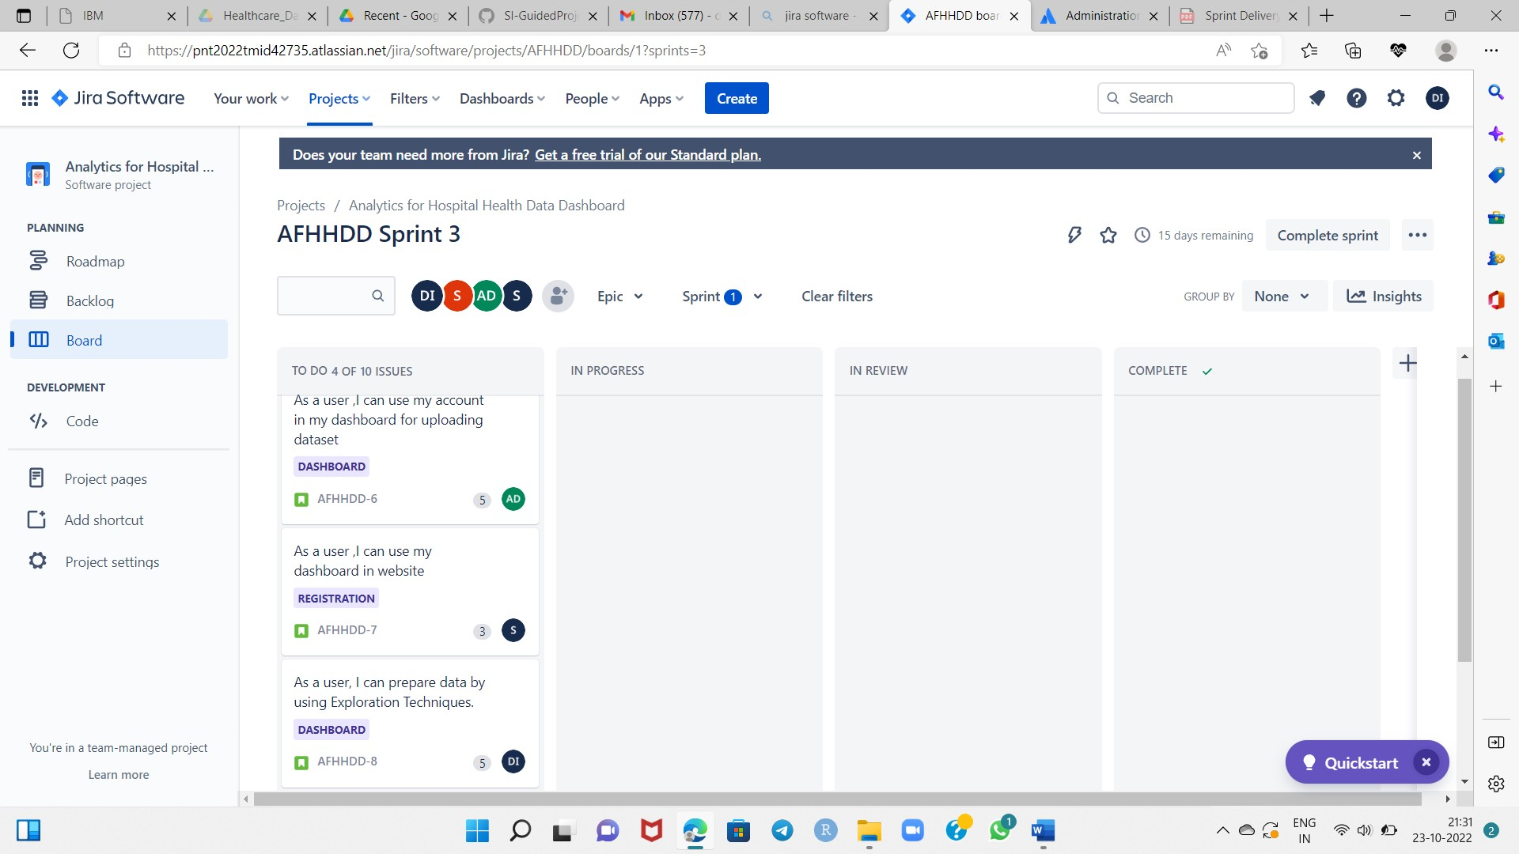

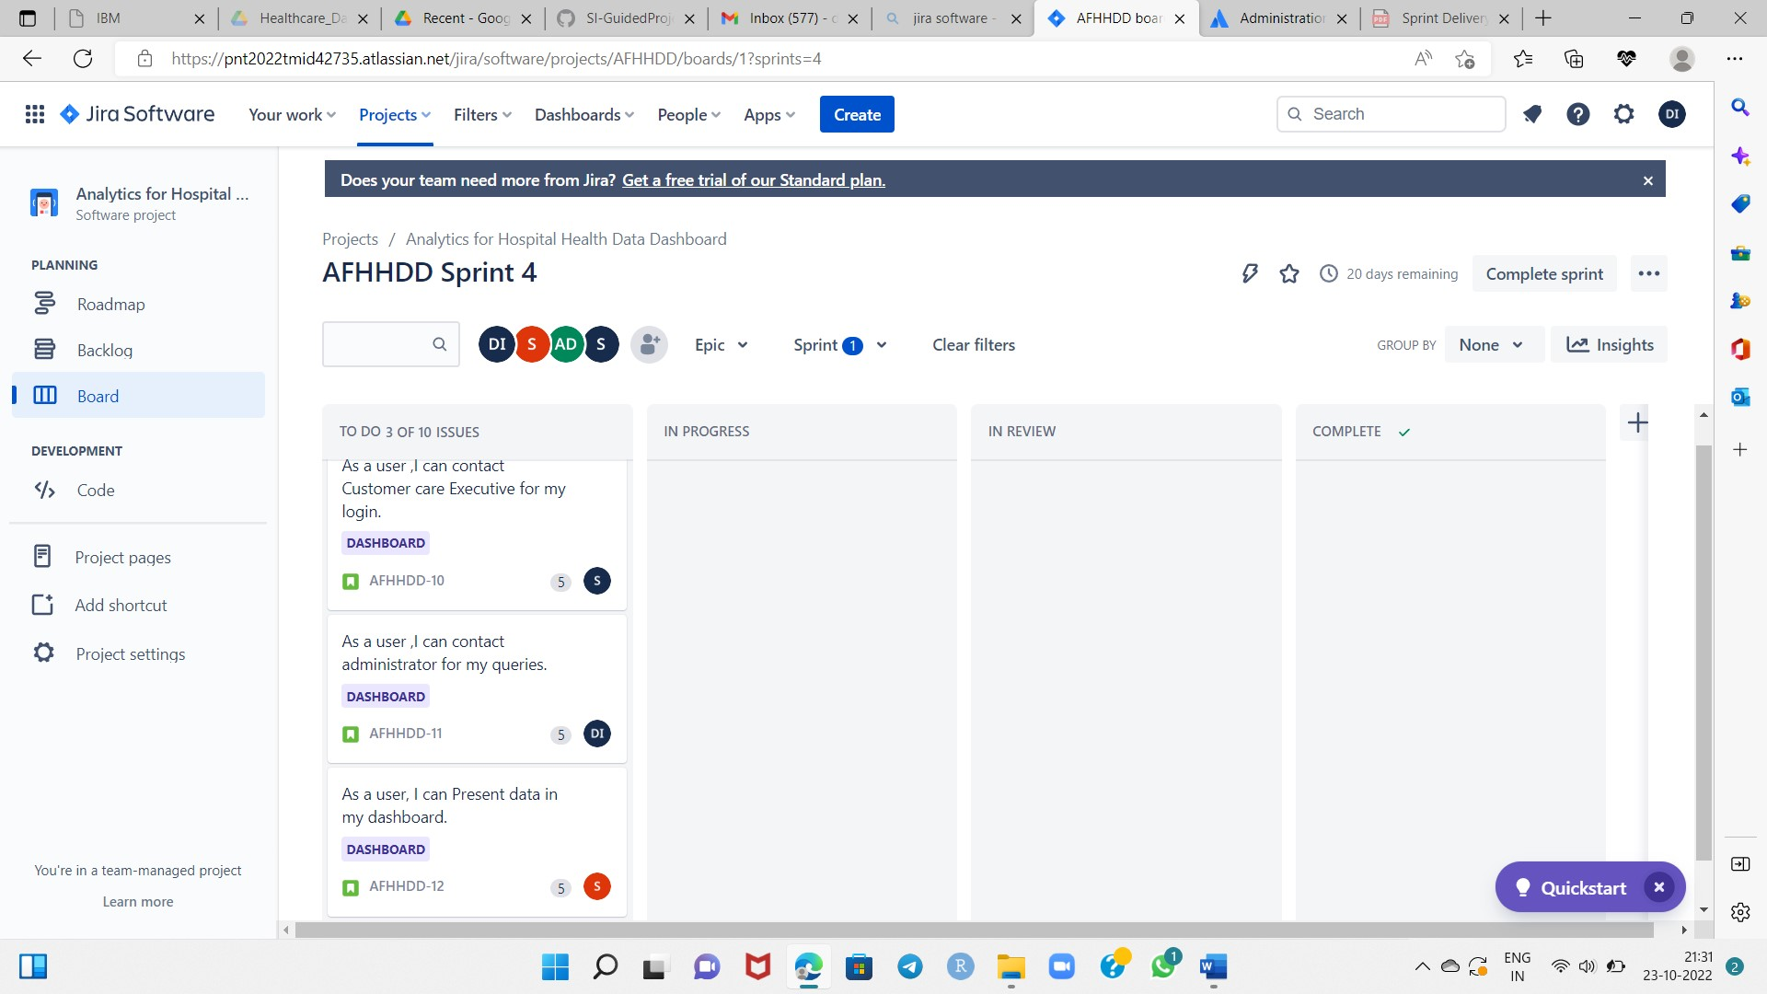

**Road Map:**

